**Source Code :-**

**Index.html**

|  |
| --- |
| <body>  Enter The name of the Book you want to add<br />  <form action="CartTest.jsp" method="post">  <input type="text" name="txt1" />  <input type="submit" name="Submit" />  </form>  </body> |

**CartTest.jsp**

|  |
| --- |
| <%@page contentType="text/html" pageEncoding="UTF-8"%>  <%@page import="javax.naming.*,pack.CartBeanRemote,java.util.List,pack.CartBeanRemote" %>  <!DOCTYPE html>  <html> <head>  <meta http-equiv="Content-Type" content="text/html; charset=UTF-8">  <title>JSP Page</title>  </head> <body>  <%! private CartBeanRemote c = null;  public void jspInit()  { try  { InitialContext ic = new InitialContext();  c = (CartBeanRemote) ic.lookup(CartBeanRemote.class.getName());  }  catch (Exception ex)  { System.out.println("Couldn't create converter bean."+ ex.getMessage());  }  }  public void jspDestroy()  { c = null; } %>  <% try  { c.initialize("ABC", "123"); }  catch(Exception e){}  c.addBook("Java 8 Cookbook"); c.addBook("Enterprise Java 7 ");  c.addBook("Java for Dummies"); c.addBook("Learn Java 8");  String str=request.getParameter("txt1");  c.addBook(str);  try  { List<String> books = c.getContents();  for( String s : books)  out.println(s +"<br />");  }  catch(Exception e)  {}  %>  </body>  </html> |

**CartBean.java**

|  |
| --- |
| package pack;  import java.util.ArrayList;  import java.util.List;  import javax.ejb.Remove;  import javax.ejb.*;  @Stateful  public class CartBean implements CartBeanRemote  { String customerName;  String customerId;  List<String> contents;  public void initialize(String person, String id)  throws Exception  { if (person == null)  { throw new Exception("Null person not allowed.");  } else  { customerName = person; }  if ( person=="ABC" && id=="123")  { customerId = id;  } else  { throw new Exception("Invalid id: " + id); }  contents = new ArrayList<String>();  }  public void addBook(String title)  { contents.add(title); }  public void removeBook(String title) throws Exception  { boolean result = contents.remove(title);  if (result == false)  { throw new Exception(title + " not in cart.");  }  }  public List<String> getContents()  { return contents; }  @Remove  public void remove()  { contents = null; }  } |

**CartBeanRemote.java**

|  |
| --- |
| package pack;  import java.util.List;  import javax.ejb.Remote;  @Remote  public interface CartBeanRemote {  public void initialize(String person, String id)  throws Exception;  public void addBook(String title);  public void removeBook(String title) throws Exception;  public List<String> getContents();  public void remove();  } |

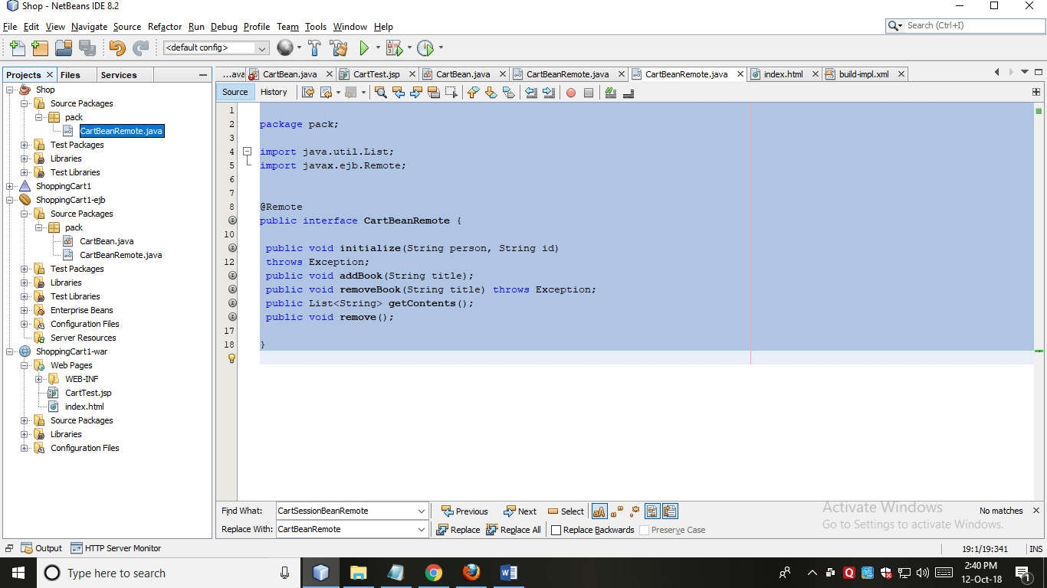

**Output:-**

